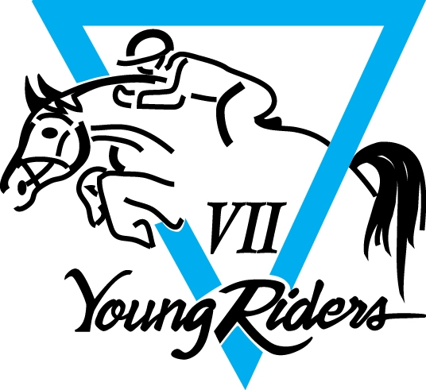

AREA VII YRAP SUMMER CAMP
JUNE 27-JULY 1, 2017
CABER FARM, ONALASKA, WA

It's summer camp time again!
Come join the fun at Caber Farms in Onalaska, WA, June 27-July 1, 2017.
Our camp theme this year is
Work Until Your Idols Become Your Rivals
Selections and team placements for Area Team Challenge and NAJYRC 2017 will also be held at this time.
Mounted Instruction will be
Area Coach John Camlin, NAJYRC Area Selectors: Anna Collier, Sarah Lorenz and Jordan Lindstedt, Debbie Rosen & Brooke Phillips
Unmounted instruction will include planning and preparation for Team Competition (Team Challenge and NAJYRC)
Camp Details
- Camp check in will be Tuesday June 27th (2p-7p). Check out will be Saturday afternoon after Ride A Test and Derby Run.
- Must have your own horse and riding experience is required.
- Levels taught will be Beginner Novice thru Intermediate.
- Camp registration price is $425 –we will also request a second check for $100 (which will be destroyed after the YR Benefit HT if the YR volunteers for 10 or more hours). If you are unable to volunteer camp fee will be $525.
  - This includes all mounted instruction for 3-4 days (show jumping and cross country group lessons and dressage will be semi-private)
  - Meals (starting with dinner on Tuesday through lunch on Saturday and snacks)
  - Stabling for one horse
  - Grounds fees, unmounted activities, t-shirt and awards.

For safety reasons we require that campers not leave Caber Farm once they have checked in. The only exception is leaving with their parent or designated adult chaperone to stay at a hotel. USEA insurance rules do not cover use of dirt bikes or otherwise motorized vehicles. If you use, you must provide personal insurance (bring copy so we have on record) and only drivers with a valid drivers license are allowed to drive. Common sense rules will also apply (no more than 2 riders on a vehicle at one time etc). This is both for their safety and for Caber Farm and USEA insurance rules.

Parents are responsible for night arrangements. Tents, RV, campers or trailers are allowed. Unfortunately, Caber Farms does not have RV hookups so generators will be allowed if staying on grounds. If enough interest, we may be able to rent large generators which would be available to rent a hookup with. Parents, please be aware that other parents will be on grounds at night in case of emergency, however, they will be sleeping in their own campers. If your child is not self-sufficient please plan to attend camp with them.

This is a volunteer run camp. Our goal is to provide a fun, safe and informative time for the riders. They will be expected to follow rules for their own safety and to be respectful of Caber Farm and the parents that are volunteering. Campers are not allowed to leave camp without their parents. All meals are included in the camp price. Parent volunteers are needed!!! This camp can not happen with out the help of the parents. We would like 1 parent for every 6 campers. The safety of the riders is of utmost importance and therefore the rider to volunteer ratio is critical. Please let me know ASAP if you are willing to volunteer. The parents who volunteered last year found it very rewarding and a wonderful opportunity to meet the area Young Riders and spend time with their own child. Most have volunteered again this year.

To register send the following:

*Payment- made payable to Area VII Young Riders
*USEA Educational Activity Participant Release Form
*USEA Emergency Medical Release Form
*USEA Stabling Form
*Parent Form- (found below)
*Camp Registration Form -(found below)
*A copy of the horse's current coggins and /or Health Papers

Registrations should be mailed to:
Area VII Young Riders
c/o Heather Carrion
161 Kent Dr.
Toutle, WA 98649
360-703-4828

Closing date is June 8, 2017. Space is limited so please register as early as possible to ensure your space. Upon receipt of your registration, you will receive an email confirmation.

Please note that we will be requiring a stall deposit check of $50 per horse. This will pay for the stripping of the stalls and cleaning of the individual camp area if you do not do it. Please write a separate check for this. This check will be destroyed after an inspection of your camp site and stalls.

Lodging for the camp is either dry camping with your own generator. Please make this a separate check payable to the Area VII Young Riders.

The Young Rider policy for cancellation prior to the closing date is to refund money, minus a $50 cancellation fee. After the closing date a refund will only be given if the slot can be filled from a waiting list. The forfeited amount, at the discretion of the YR coordinator, can be applied to the Young Riders fund raising.

There is a non-Young Rider fee of $35. Please be sure you have renewed your membership this year at the proper level.

USEA Forms can be found at the USEA website, www.useventing.com, under education /forms. Scroll down to find the forms for Stabling, Emergency Medical Release and Educational Activity Participation Release. The Parent Form and the Camp Registration form are found at the end of this information. Upon receipt of your registration you will receive a confirmation email from Barb or Heather. If you do not, please contact me.

If you haven't seen the pictures from 2016 Summer Camp- please visit the Area VII Young Riders Website, www.areavii.org/YR check out the fun! There is a lot of other information on the Young Rider program there as well! .

We hope we will see you at camp this year!

All registration is available at the Area VII Young Riders’ website as well as FB links. www.areavii.org/YR
Join us at our FB page Area VII Young Riders

If you have any questions please contact us.
Karla Nichwander 770-314-7876 krnichwander@gmail.com
Barb Jensen 541-760-9102 barbj@actionnet.net
Heather Carrion 360-703-4828 hbcarrion@gmail.com

Barb Jensen
Heather Carrion
USEA Area VII Young Riders Summer Camp Co-Chairs

